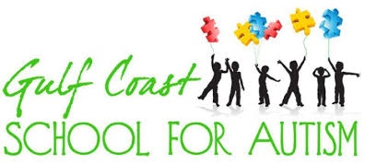

Media Release Form
2019-2020

Student Name______________________________
The media release may include one or all of the following: Video recordings, television, radio, newspaper, printed material or web publications (school website & social media pages).

____ Gulf Coast School for Autism has my permission to include my child in any media release for the school.

____ Please DO NOT include my child in any type of publication.

Parent Signature__________________________
Date ___________

